**Understanding and Using Servos in Projects:**

# **Arduino Servo Motors**

Servo motors are great devices that can turn to a specified position.

Usually, they have a servo arm that can turn 180 degrees. Using the Arduino, we can tell a servo to go to a specified position and it will go there. As simple as that!

Servo motors were first used in the Remote Control (RC) world, usually to control the steering of RC cars or the flaps on a RC plane. With time, they found their uses in robotics, automation, and of course, the Arduino world.

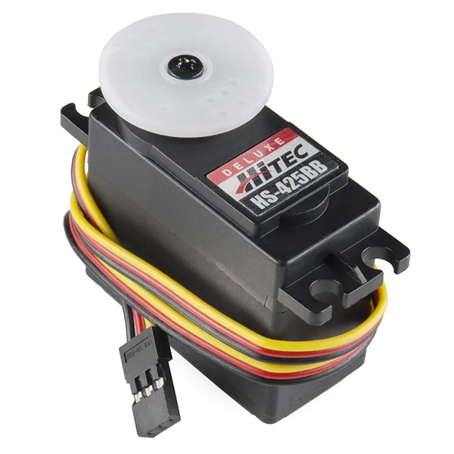

Here we will see how to connect a servo motor and then how to turn it to different positions.

We will need the following things:

* An Arduino board connected to a computer via USB
* A servo motor
* Jumper wires

## **How to Connect Them:**

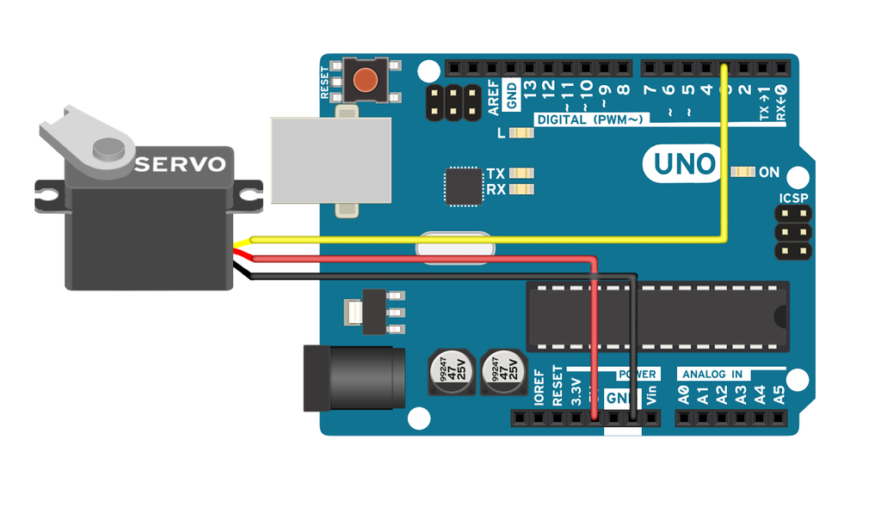

A servo motor has everything built in: a motor, a feedback circuit, and most important, a motor driver. It just needs one power line, one ground, and one control pin.

Following are the steps to connect a servo motor to the Arduino:

* The servo motor has a female connector with three pins. The darkest or even black one is usually the ground. Connect this to the Arduino GND.
* Connect the power cable that in all standards should be red to 5V on the Arduino.
* Connect the remaining line on the servo connector to a digital pin on the Arduino.

## **Code**

// Include the Servo library

#include <Servo.h>

// Declare the Servo pin

int servoPin = 3;

// Create a servo object

Servo Servo1;

void setup()

{

// We need to attach the servo to the used pin number

Servo1.attach(servoPin);

}

void loop()

{

// Make servo go to 0 degrees

Servo1.write(0);

delay(1000);

// Make servo go to 90 degrees

Servo1.write(90);

delay(1000);

// Make servo go to 180 degrees

Servo1.write(180);

delay(1000);

}

If the servo motor is connected on another digital pin, simply change the value of servoPin to the value of the digital pin that has been used.

**OUTPUT:**

